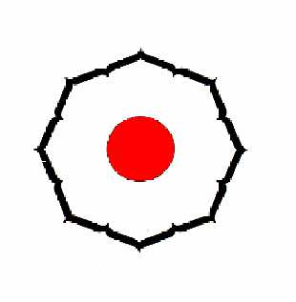1st KODOKAN JUDO KATA INTERNATIONAL TOURNAMENT 2007
TOURNAMENT REGULATIONS

We should like to take advantage of this occasion to encourage the development of correct Kodokan judo
1. | Tournament Name | 1st Kodokan Judo Kata International Tournament 2007
2. | Date | October 27 (Sat) and 28 (Sun), 2007
3. | Venue | Kodokan Judo Institute 1-16-30 Kasuga, Bunkyo-ku, Tokyo, Japan 112-0003
4. | Organized by | Kodokan Judo Institute and All Japan Judo Federation
5. | Schedule | Oct. 25 (Thu.) 26 (Fri.) Arrival Referees Meeting Delegates Meeting
 |  | 27 (Sat.) 28 (Sun.) 29 (Mon.) Draw Competitions (Preliminaries) Competitions (Finals) Awarding Ceremony Kata Seminars Departure
6. | Contests Rules | (1) Contests will be held in the four events below.

Nage no KataKatame no KataKime no KataJu no Kata
  - (2) Quota of competitors a) In each Kata, a maximum of ten (10) pairs of competitors (20 persons in total) shall enter the contest.
  - b) The composition shall be two (2) pairs of Japanese competitors (4 persons in total) and maximum of eight (8) pairs of competitors from overseas.
  - (3) Judging a) In each kata, all contests shall be refereed by five (5) judges including one chief judge. b) The score shall be determined by totaling the scores of the 3 judges, discarding the highest and lowest scores, and converted to a 100-point scale. c) The contests shall be conducted in accordance with Kodokan Judo Kata Scoring Rules. d) In each kata, there shall be five judges in total; two judges from Japan and three
  - judges from overseas. e) The organizing committee shall supply any replacement judge(s), if necessary.
- (4) Selection system for competitors and judges a) The participants from overseas shall be selected in accordance with attached

detail selection system for competitors and judges from overseas. b) Japanese competitors and judges will be selected by the organizing committee.
1/2
- InvitationConditions
- Judo-gi
- Awards
- Kata Seminar
- Insurance
- Transportation
- Accommodation
- Entry
- Tournament Secretariat

(5) System of competition
a) In the preliminaries, all ten (10) pairs of competitors in each kata will perform
their kata and the three (3) pairs with the best scores will advance to the finals
the next day.
b) In the finals, three (3) pairs of competitors in each kata will again perform their kata and the highest scored pair will be awarded the gold medal, the second highest silver and the third highest bronze.
- (6) Contest Area The contest area shall be 9m X 9m.
- (1) Invitation Period 4 nights and 5 days from Oct. 25 (Thu.) Lunch through Oct. 29 (Mon.) Breakfast.
  - (2) Air Fare a) Competitors are responsible for their own airfares. b) The Organizing Committee will provide round trip air tickets (Discount rate/
  - Economy Class) to judges.
- (3) Subsistence Expenses a) Hotel room charges shall be borne by the Organizing Committee on the condition that participants stay at the designated hotel. b) Breakfast, lunch and dinner coupons will be provided for use in the designated restaurant in the hotel.

c) Participants are responsible for all expenses other than specifically stated above and for any period before and/or after the invitation period.
The size of Judo-gi and any publicity placed on the Judo-gi must be in conformity with IJF rules. All competitors shall wear only WHITE JUDO-GI for the contest.
Gold, silver, and bronze medals will be awarded.
On October 28, 2007, after the awarding ceremony, the kata seminars will be held at Kodokan Judo Institute for tournament participants.
Competitors are expected to arrange for appropriate insurance coverage for themselves for the period between their departure from and return to their home Competitors must assume all responsibility for accidents and injuries as well as possible civil liabilities for their participation.
Transportation between Narita airport and the hotel for arrivals on Oct. 25 and departures on Oct. 29 will be provided by the organizing committee.
Entry Forms with names of participants and Travel Schedule Forms should be sent to the Organizing Committee NO LATER THAN AUGUST 20, 2007.
Organizing Committee of the Kodokan Judo Kata International Tournamentc/o Kodokan Judo Institute1-16-30 Kasuga, Bunkyo-ku, Tokyo, 112-0003, JapanE-mail: kata2007@kodokan.orgTel: +81-3-3818-4172 / Fax: +81-3-3814-2918
2/2
KODOKAN JUDO KATAINTERNATIONAL TOURNAMENT
講道館柔道「形」国際競技大会
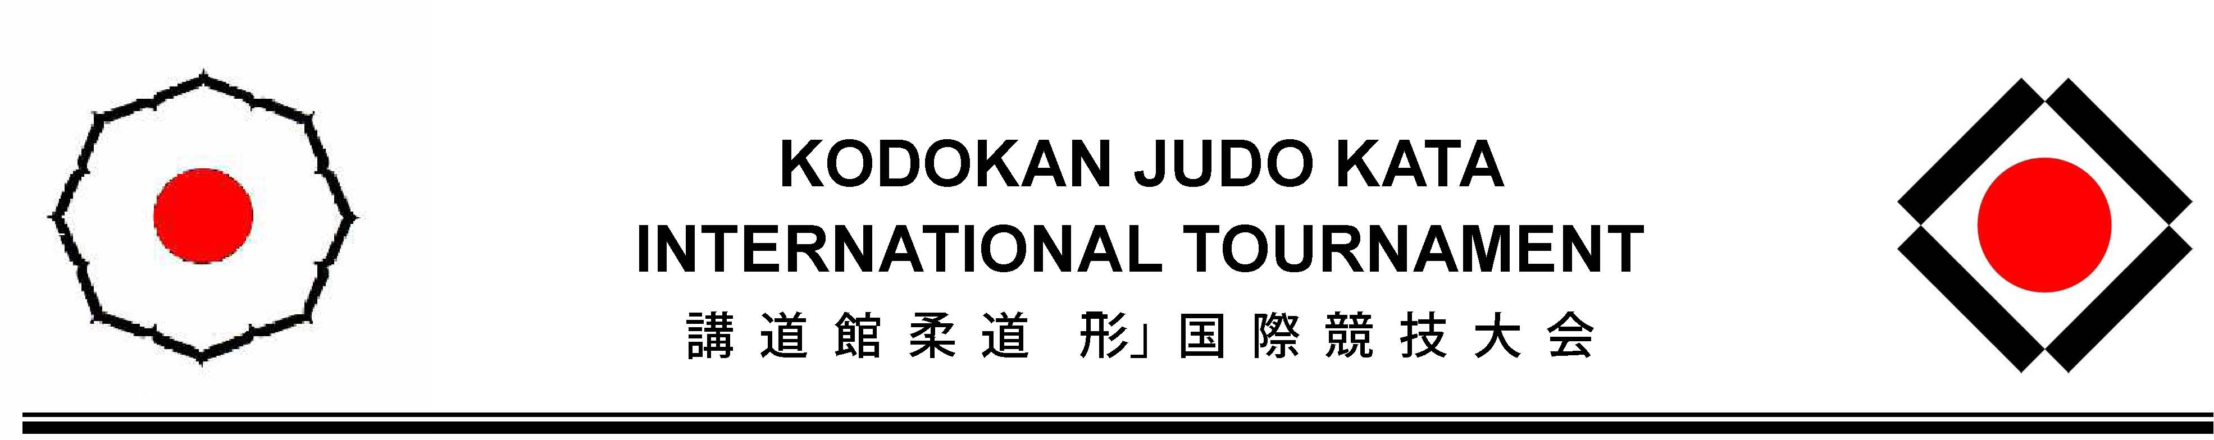
Selection Systems for Judge and Competitor
Events
1. Nage no Kata 2. Katame no Kata 3. Kime no Kata 4. Ju no Kata
Quota for Judge (person) and Competitor (pair)
 | Nage no Kata |  | Katame no Kata |  | Kime no Kata |  | Ju no Kata
 | Judge | Comp | Judge | Comp | Judge | Comp | Judge | Comp
EJU | 1 | 2 | 1 | 2 | 1 | 2 | 1 | 2
PJU | 1 | 2 | 1 | 2 | 1 | 2 | 1 | 2
AJU, JUA, OJU | 1 | 3 | 1 | 3 | 1 | 3 | 1 | 3
JPN | 2 | 2 | 2 | 2 | 2 | 2 | 2 | 2
Special | - | 1 | - | 1 | - | 1 | - | 1
Total | 5 | 10 | 5 | 10 | 5 | 10 | 5 | 10

Selection system in detail
1) Europe (Judge: 4 persons, Competitor: 8 pairs) 4 Judges shall be selected by EJU. 8 pairs of competitors shall be selected by the organizing committee.
2) Pan America (Judge: 4 persons, Competitor: 8 pairs) 4 Judges shall be selected by PJU. 8 pairs of competitors shall be selected by PJU.
3) Africa, Asia, and Oceania (Judge: 4 persons, Competitor: 12 pairs) Judge Selection: 4 judges from 3 continents: Africa, Asia, and Oceania, shall be selected by following system.
a) Respective judges, who wish to participate in the tournament, must send his or her application form to the organizing committee directly. b) All applicants must obtain approval of his or her participation from their own national judo federations. c) The organizing committee shall select one judge for respective katas (4
1
judges in total) from applicants. d) After the selection of judges has been done, the invitation shall be sent to selected judges by the organizing committee.
Competitor Selection: 12 pairs of competitors from 3 continents: Africa, Asia, and Oceania, shall be selected by following system.
a) Respective pairs of competitors, who wish to participate in the tournament, must send their application form to the organizing committee directly.
b) All applicants must obtain approval of their participation from their own national judo federations. c) The organizing committee shall select three pairs of competitors for
respective katas from applicants according to the tournament regulation. d) Selection priorities: 1st continental quota, 2nd past results, 3rd others. e) After the selection of competitors has been done, the invitation shall be
sent to selected competitors by the organizing committee.
4) JAPAN (Judge: 8 persons, Competitor: 8 pairs) 8 Judges and 8 pairs of competitors shall be selected by the organizing committee.
5) A SPECIAL quota for competitor (4 pairs) Regardless of continent, country or region, if the organizing committee recognizes the pair of competitors enough qualified, they shall be able to participate as SPECIAL.
6) Others In the event that someone withdraws from the competition, the organizing committee can fill a vacancy of judge or competitor.
Selection timeline
August 20, 2007 Deadline for the submission of entry
September 30, 2007 Organizing committee to confirm the quota for judges and competitors from Africa, Asia, Oceania and SPECIAL
2
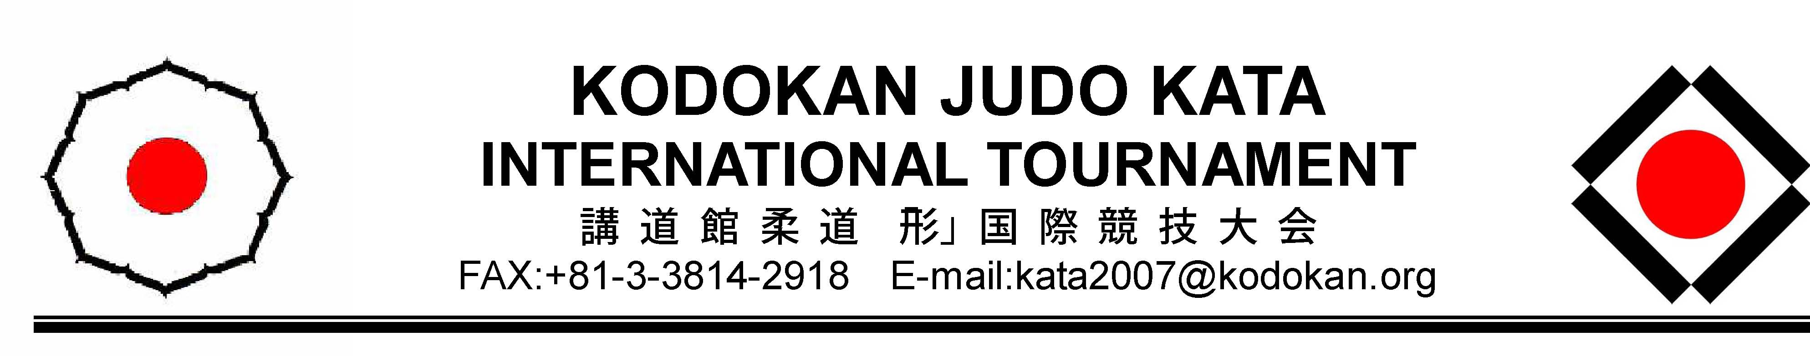
KODOKAN JUDO KATAINTERNATIONAL TOURNAMENT
講道館柔道「形」国際競技大会
FAX:+81-3-3814-2918 E-mail:kata2007@kodokan.org
ENTRY FORM
For Judge and CompetitorPlease fill in this form and send it back to the Organizing Committee by e-mail(kata2007@kodokan.org) or fax (+81-3-3814-2918) no later than August 20, 2007.
Nage no Kata Katame no Kata Kime no Kata Ju no Kata JUDGE

 | Last Name | First Name | Date of birth (m/d/y) | Dan grade
Mr. | Declercq | Raymond | 12/04/'52 | Kodokan ( 6 ) Your NF ( 7 )

COMPETITOR
 | Last Name | First Name | Date of birth | Dan grade
Tori | Mr. De Maerteleire | Dirk | 03/08/'70 | Kodokan ( ) Your NF ( 5 )
Uke | Mr. Inghelbrecht Ms. | Christophe | 16/04/'74 | Kodokan ( ) Your NF ( 4 )

BELGIUM / BELGISCHE JUDO BOND
Nationality Name of Federation / Association
Judo Career: 3rd European Championships 2007, Wuppertal (GER), kime-no-kata // 1st European Master Championships 2007, Tours (FRA), Kime-no-kata // 5th European Championships 2006, Torino (ITA), Kime-no-kata, // 4th World Master Championships 2006, Tours (FRA), Kime-no-kata, // 7th World Master Championships, Sao Paulo (BRA), Kime-no-kata
E-mail: | dirk@mediaventures.be |  | Fax: | +32 9 231 89 20
17/08/'07
Date |  | Name of President |  | Signature

