
KODOKAN JUDO KATAINTERNATIONAL TOURNAMENT
講道館柔道「形」国際競技大会
FAX:+81-3-3814-2918 E-mail:kata2007@kodokan.org
Tokyo, September 5, 2007
President of Judo Federation
Cc.Mr. De Maerteleire Dirk Mr. Inghelbrecht Ms. Christophe
INVITATION LETTER
The 1st KODOKAN JUDO KATA INTERNATIONAL TOURNAMENT 2007 is going to take place under the joint auspices of the KODOKAN JUDO INSTITUTE and the ALL JAPAN JUDO FEDERATION on October 27 & 28, 2007 at the Kodokan Judo Institute in Tokyo, Japan. This tournament will be held for the purpose to encourage the development of correct Kodokan Judo.
In order to make the tournament successful, the participation of many excellent KATA pairs of competitors is indispensable.
We have great pleasure in inviting your KATA pair of competitors mentioned below to this tournament. We have selected them according to the result of organizing committee examination.
Kime no KataTori-Mr. De Maerteleire Dirk Uke-Mr. Inghelbrecht Ms. Christophe
Please find the attached tournament regulations for your reference. We hope you will kindly understand our purport of the above and accept our invitation.
We are looking forward to welcoming them to the 1st KODOKAN JUDO KATA INTERNATIONAL TOURNAMENT 2007.
If you have any questions, please feel free to contact us.
Sincerely yours,
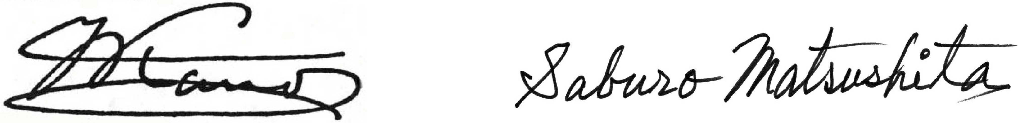

Yukimitsu KANO | Saburo MATSUSHITA
President | Chairman of Executive Committee
Kodokan Judo Institute | 1st Kodokan Judo KATA
All Japan Judo Federation | International Tournament 2007

